Website corrections points – V4

- Need to classify under Lidar Annotation as below
3. Lidar Annotation
a. 3D Cuboids Annotation
b. 3D Semantic Annotation
- We need to add a G- Meet Link in schedule an appointment
That should be remain as Schedule an appointment remove G meet
under that we need to add a G - meet link with the time and Date selection option
Please refer below images
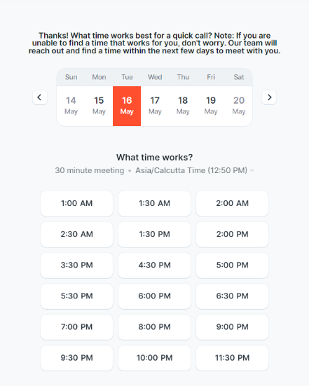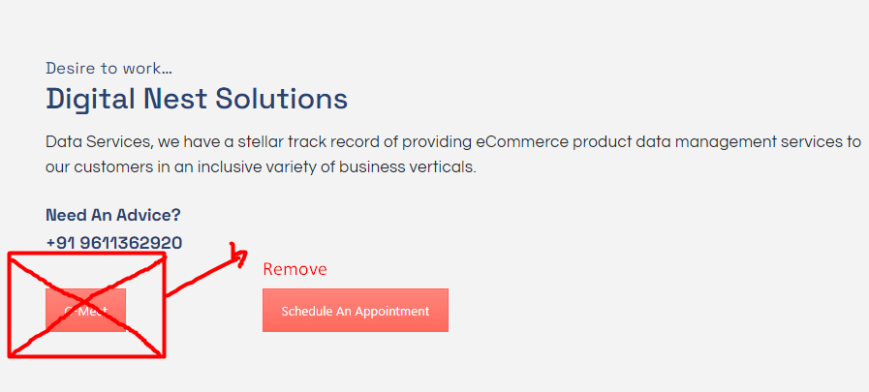
Email should go to them like below
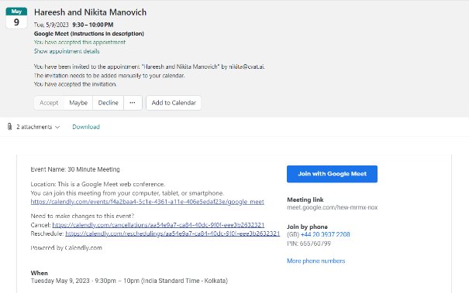

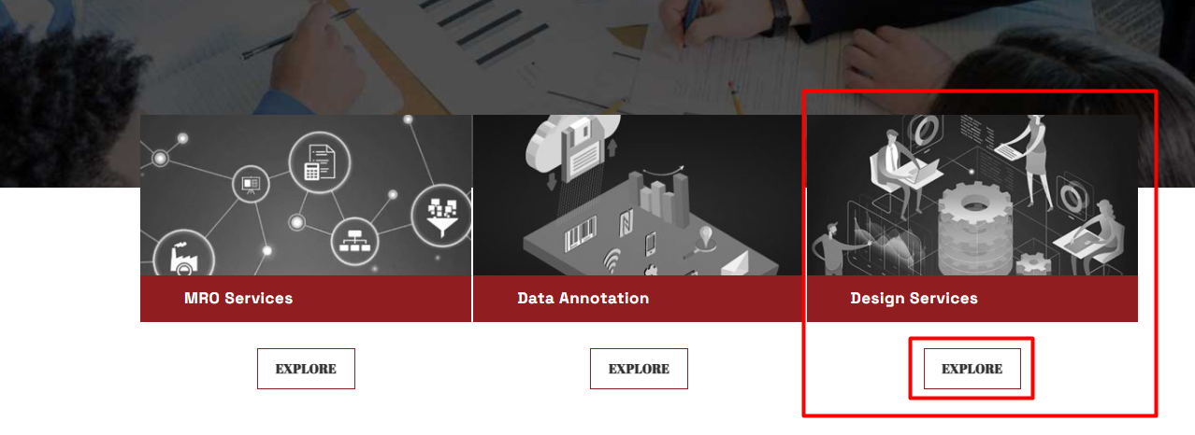
- If we click on the Explore under Design services
Its taking us directly to Interior design services, it should take us to refer both interior and PV design services

- We are not receiving any email for contact us details
We should receive an email to info@digitalnestsolutions.com
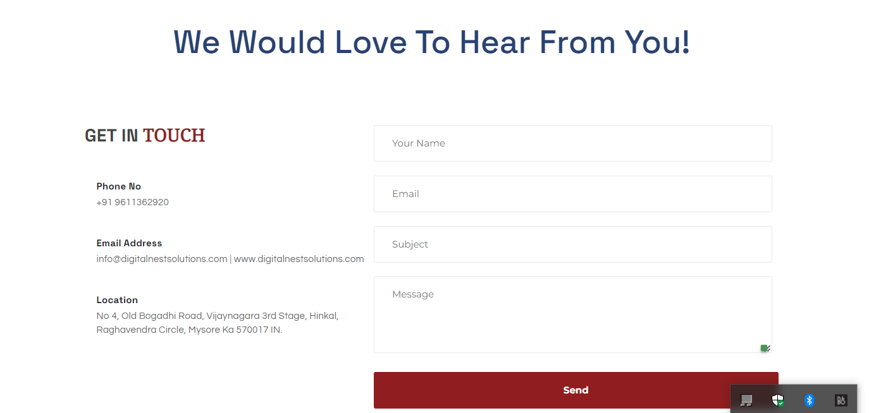

- Need to update the DNS Overview as below -
A Multi-variant IT Data and Design Service Provider in Mysore, Karnataka (India). We are family-owned professional-run business, provides a full range of IT / BPO services on Data Management Services, Data Mining, Data Annotation services for Artificial Intelligence/Machine learning industries, Engineering Design Services through Solid Edge, Catia, AutoCAD. To exceed our client’s expectations, we use our technical skills as well as industry insights. Alternatively, we constantly refine our processes to ensure our clientele gets cost-effective and robust solutions.

- Remove the marked image in all services and place heading of the services over the image
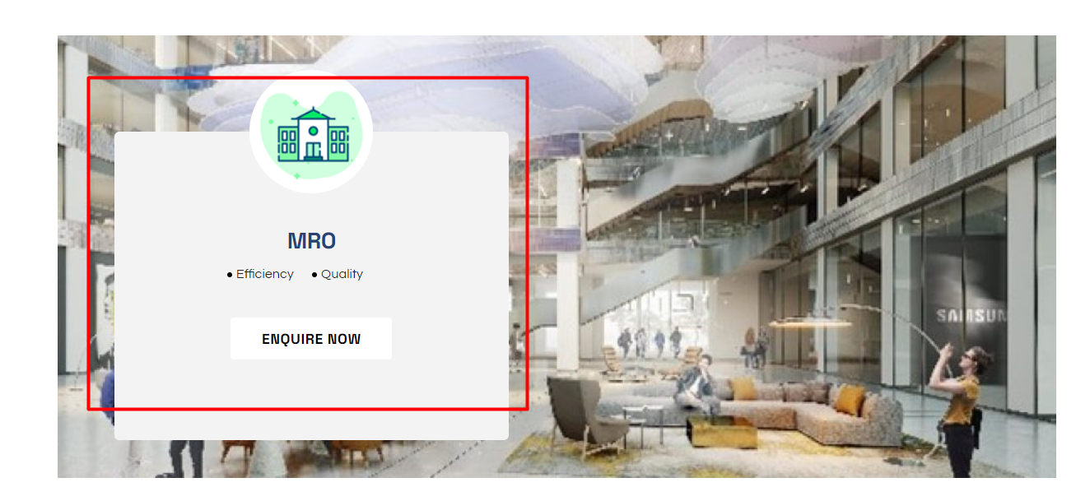

- Remove the click option for Our services as it is taking us to MRO services which is not necessary

- Under Why digital nestsolutions we need to add ISO Certificate( Attached )

- Extend blue color to match other two rectangles
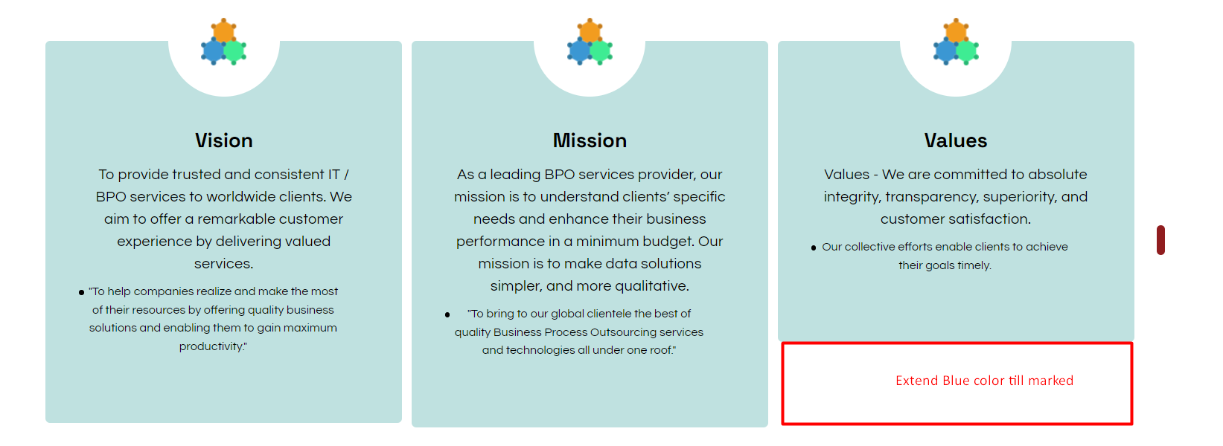

- Need to update
COMPREHENSIVE SOLUTION FOR SOLAR PV DESIGN to
COMPREHENSIVE DESIGN SOLUTIONS FOR SOLAR PV SYSTEMS – Experts in Preparing Pre-Permit Plan Sets

- Make a marked place as heading and give background
Has attached image for around the world – update the image
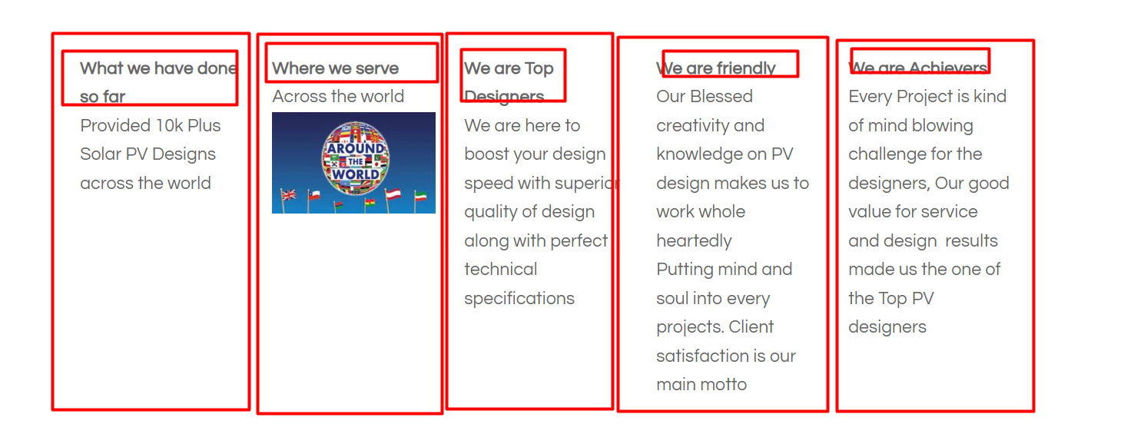
Provided info is for PV design
Make changes to other pages as below
- Remove the below in MRO services Page
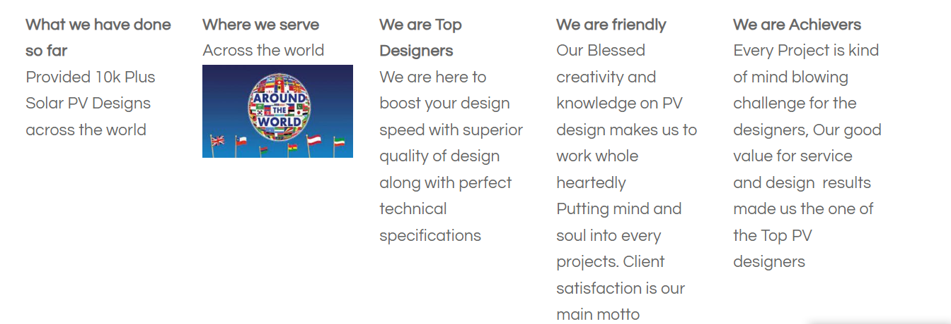
- Update as below expect for PV design services
1. What we have done so far
Provided 10k Plus Projects across the world
2. Where we serve
Across the world
(Image Attached)
3. We are Top Designers
We are here to boost your design speed with superior quality of design along with perfect technical specifications
4. We are friendly
Our Blessed creativity and knowledge on Design makes us to work whole heartedly
Putting mind and soul into every projects. Client satisfaction is our main motto
5. We are Achievers
Every Project is kind of mind blowing challenge for the designers, Our good value for service and design results made us the one of the Top Service Providers
- Under Landmark Annotations
Arrange the images and Words Properly
Images are attached
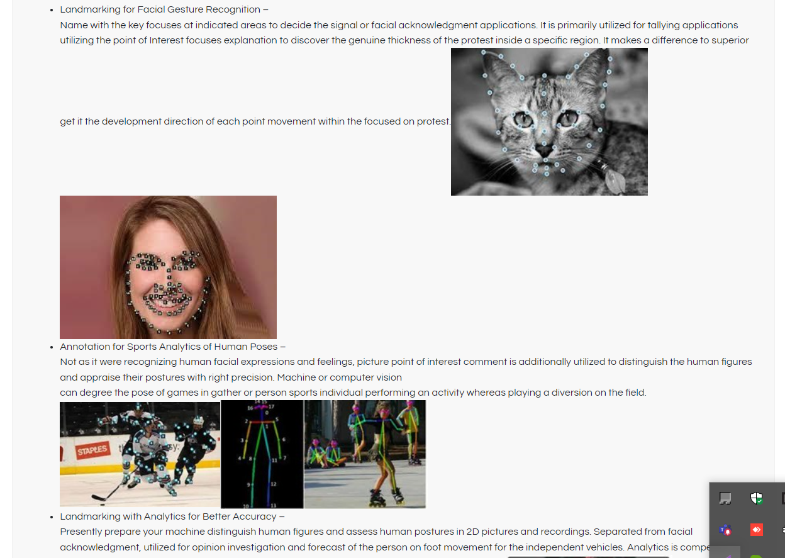
- Remove the unnecessary Blank spaces in the website
- High Resolution images have been attached
Kindly update the images with same Size and make look more attractive
- Need to update Annotation introduction as
DIGITAL NEST SOLUTIONS specializes in in all types of Data Annotation services.
We have the expertise, processes and a human-in-the-loop platform to meet the challenging AI projects and we do it all within your timeframe and budget. Which supports the sectors/ Industries like Waste management, Autonomous Driving, Agriculture,
Health Care, Logistics, Retail Etc….

